**Project Documentation**

Project Title

# 1. Introduction

* **Project Title:** COOK BOOK: Your Virtual Kitchen Assistant
* **Team ID: NM2025TMID41040**
* **Team Leader:** ALFIDHA.M(24bca02acas@gmail.com)
* **Team Members:**
  + Divya sree.P([24bca06acas@gmail.com](mailto:24bca06acas@gmail.com))
  + Ramya.B([24bca38acas@gmail.com](mailto:24bca38acas@gmail.com))
  + Farjana.R([24bca07acas@gmail.com](mailto:24bca07acas@gmail.com))

# 2. Project Overview

* **Purpose:** SB Works connects clients and freelancers through project postings, bidding, and real-time communication.
* **Features:**
  + Project posting and bidding
  + Secure chat system
  + Feedback and review system
  + Admin control panel

# 3. Architecture

* **Frontend:** React.js with Bootstrap and Material UI
* **Backend:** Node.js and Express.js managing server logic and API endpoints
* **Database:** MongoDB stores user data, project information, applications, and chat messages

# 4. Setup Instructions

* **Prerequisites:**
  + Node.js
  + MongoDB
  + Git
  + React.js
  + Express.js **–** Mongoose **–** Visual Studio Code
* **Installation Steps:**

# Clone the repository git clone

# Install client dependencies cd client npm install

# Install server dependencies cd

../server npm install

# 5. Folder Structure

SB-Works/

|-- client/ # React frontend

|__components/ L__ pages/

|__ server/ # Node.js backend

|__routes/

|__ models/

|__ controllers/

# 6. Running the Application

* **Frontend:**

cd client npm start • **Backend:**

cd server npm start

* **Access:** Visit http://localhost:3000

# 7. API Documentation

* **User:**
  + /api/user/register
  + /api/user/login
* **Projects:**
  + /api/projects/create
  + /api/projects/:id • **Applications:** /api/apply
* **Chats:**
  + /api/chat/send **–** /api/chat/:userId

# 8. Authentication

* JWT-based authentication for secure login
* Middleware protects private routes

# 9. User Interface

* Landing Page
* Freelancer Dashboard
* Admin Panel
* Project Details Page

# 10. Testing

* Manual testing during milestones
* Tools: Postman, Chrome Dev Tools

1. **Screenshots or Demo**

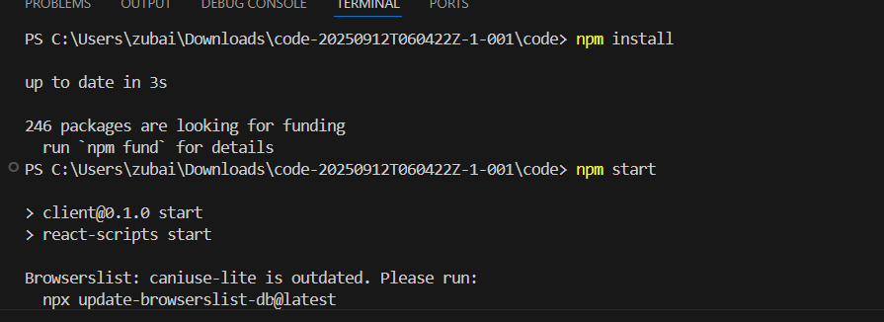

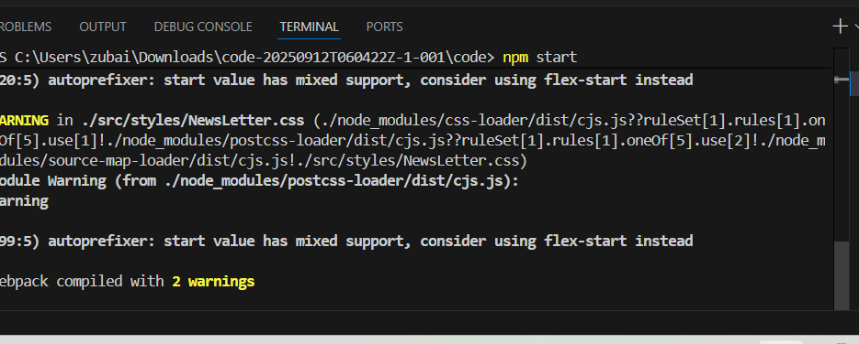

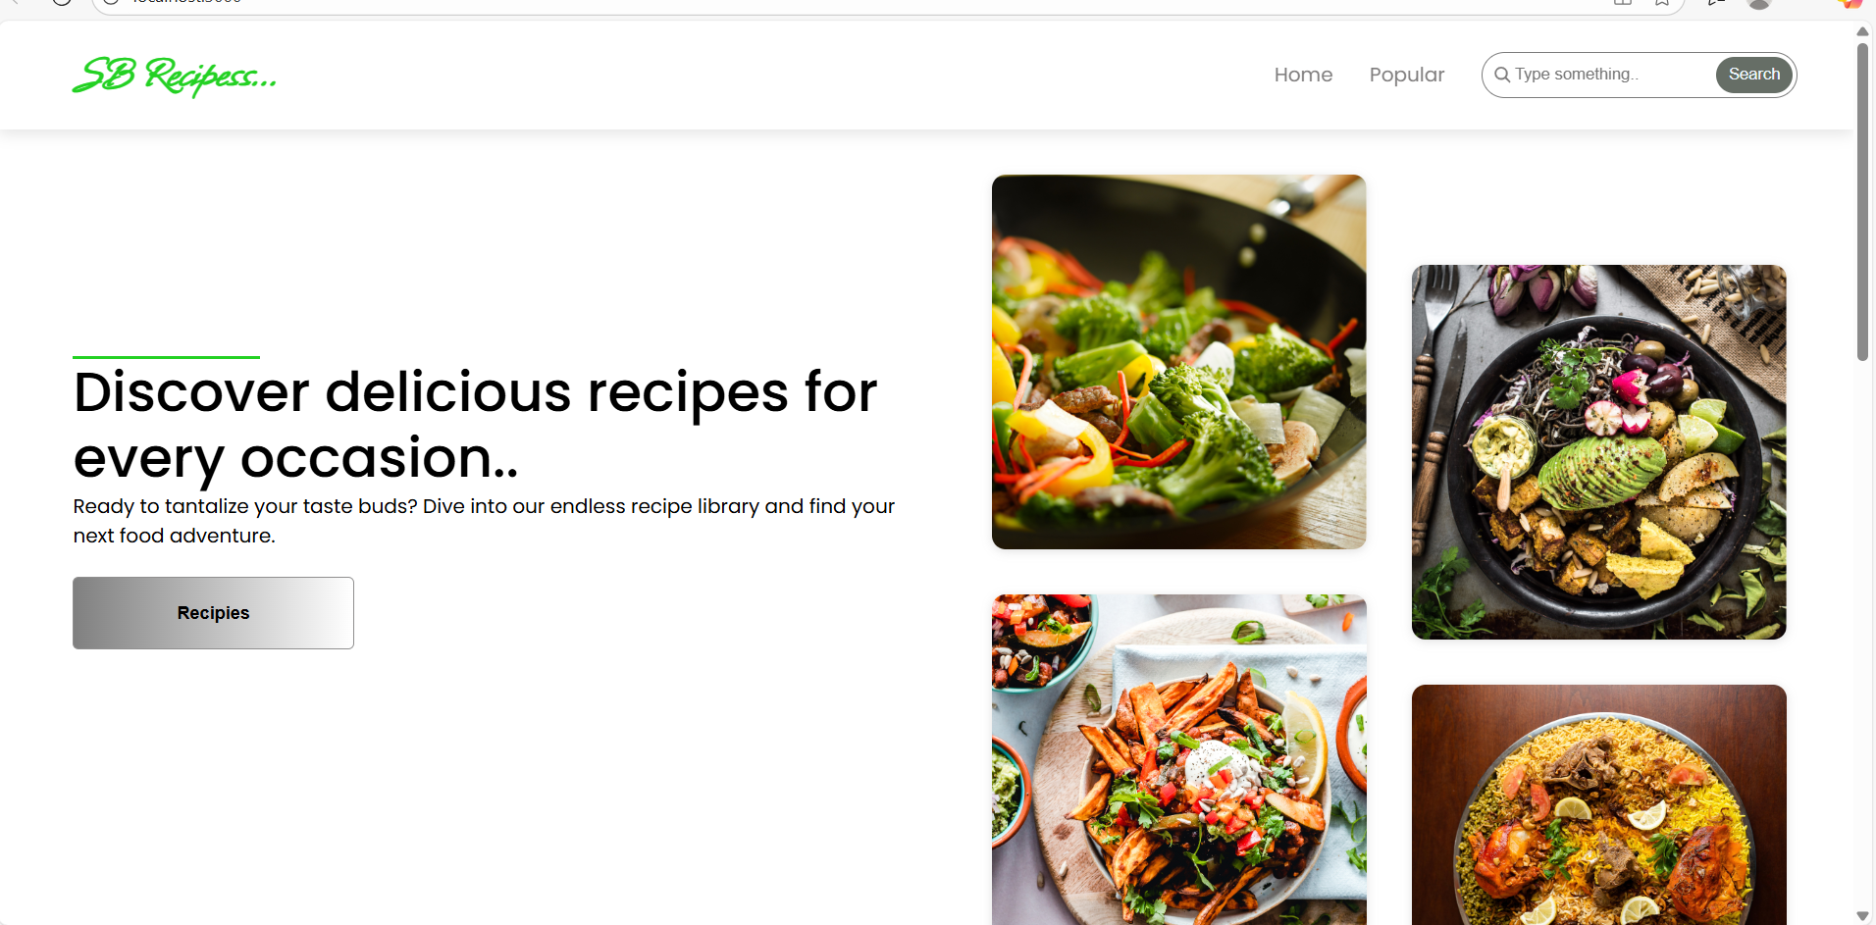

1. **Known Issues:** Nil
2. **Future Enhancements :**

• **AI-based Recipe Suggestions** – Recommend recipes to users based on ingredients they already have.

• **Meal Planning & Grocery List** – Auto-generate a weekly meal plan with a shopping list.

• **Nutritional Analysis** – Show calories, proteins, carbs, and fats for each recipe.

• **Voice Assistance** – Step-by-step cooking instructions with voice guidance.

• **Multi-language Support** – Recipes available in different languages.

• **Community Features** – Allow users to share, rate, and comment on recipes.

• **Smart Kitchen Integration** – Connect with IoT devices (smart ovens, timers).

• **Offline Mode** – Let users access saved recipes without internet.

• **Advanced Search & Filters** – Filter by diet (vegan, keto, gluten-free), difficulty, or cooking time.

• **Video Tutorials** – Short video clips for key recipe steps.